-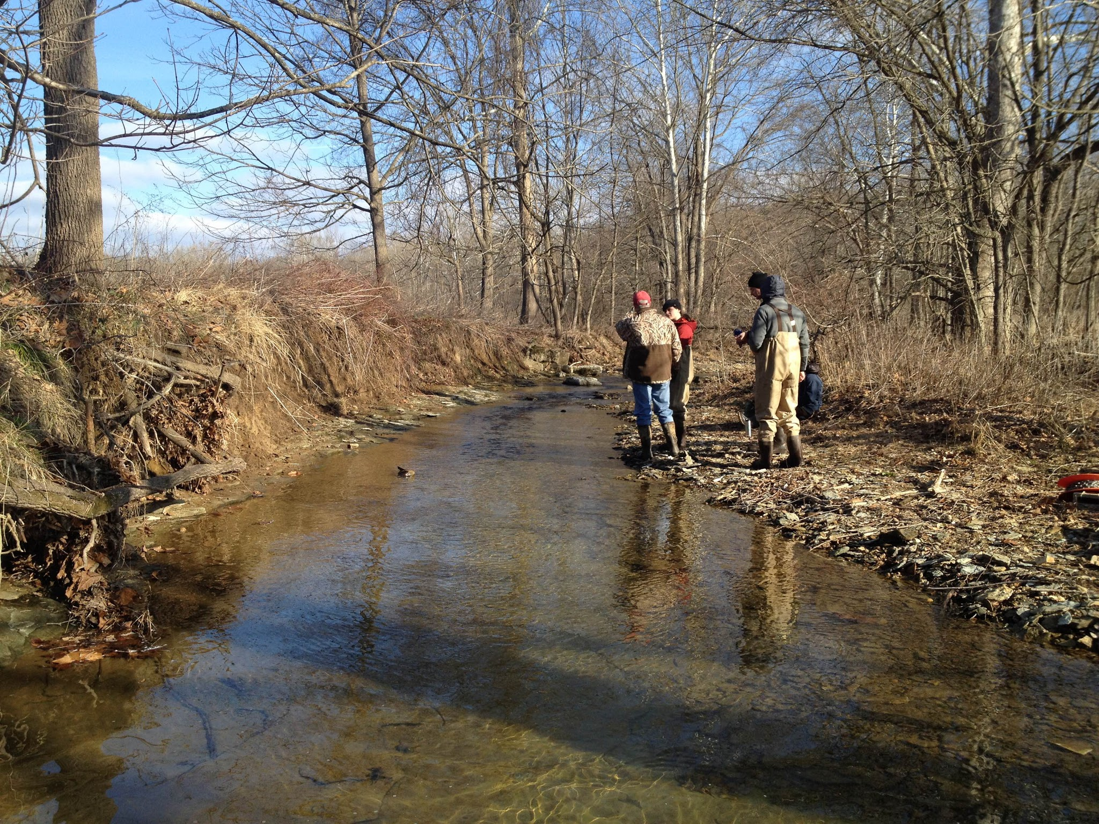

**Stephen’s Creek**

An analysis of seasonal & temporal changes of a headwater stream in southern Indiana

**Amanda Nurre, Erica Walker, Lucas Graham, James Bennett, Bardh Xerxa**

Indiana University, 2016

# 

# I. Introduction

This report summarizes a variety of chemical, physical and biological characteristics of Stephen’s Creek in Monroe County, Indiana from January-April of 2016. The primary focus for comparative data will be on macroinvertebrate and fish survey data. We look at how Stephen’s Creek compares with other Indiana streams and to historical data gathered at this sampling site over a ten year period beginning in 2006. Historical data was gathered by previous Indiana University Stream Ecology students throughout their respective coursework.

# 

# II. Site Description

Stephen’s Creek is located in Monroe County, Indiana on the eastern edge of the city of Bloomington (39.1946, -86.4341). A 100-meter site was selected by a group of Indiana University graduate students for a semester-long project beginning in January of 2016 (Figure 1). The included watershed area for the Stephen’s Creek Upper Reach was 8.57 km2. The watershed area encompassed a total stream length of 45.78 km with a drainage density of 5.34 km km-2. The study reach elevation was 228 m MSL while the watershed maximum elevation was 297 m MSL. Mean slope of the main channel was 0.8%.

Land use estimates within the watershed were dominated by forest at approximately 88%. Eight percent of the land was classified as agriculture and 4% as urban; remaining area was classified as non-vegetated land cover. Soil types in the sub-basin were dominated by Berks-Weikert complex (BkF), which exhibits 25-75% slopes (USDA, 1981). This soil type is typically well-drained, is often used as woodland, and can present a severe erosion hazard. Land slope and soil types reflect features of Southern Indiana’s Mitchell Plain, which is characterized by karst topography and rapid runoff (Fowler & Wilson, 1996).

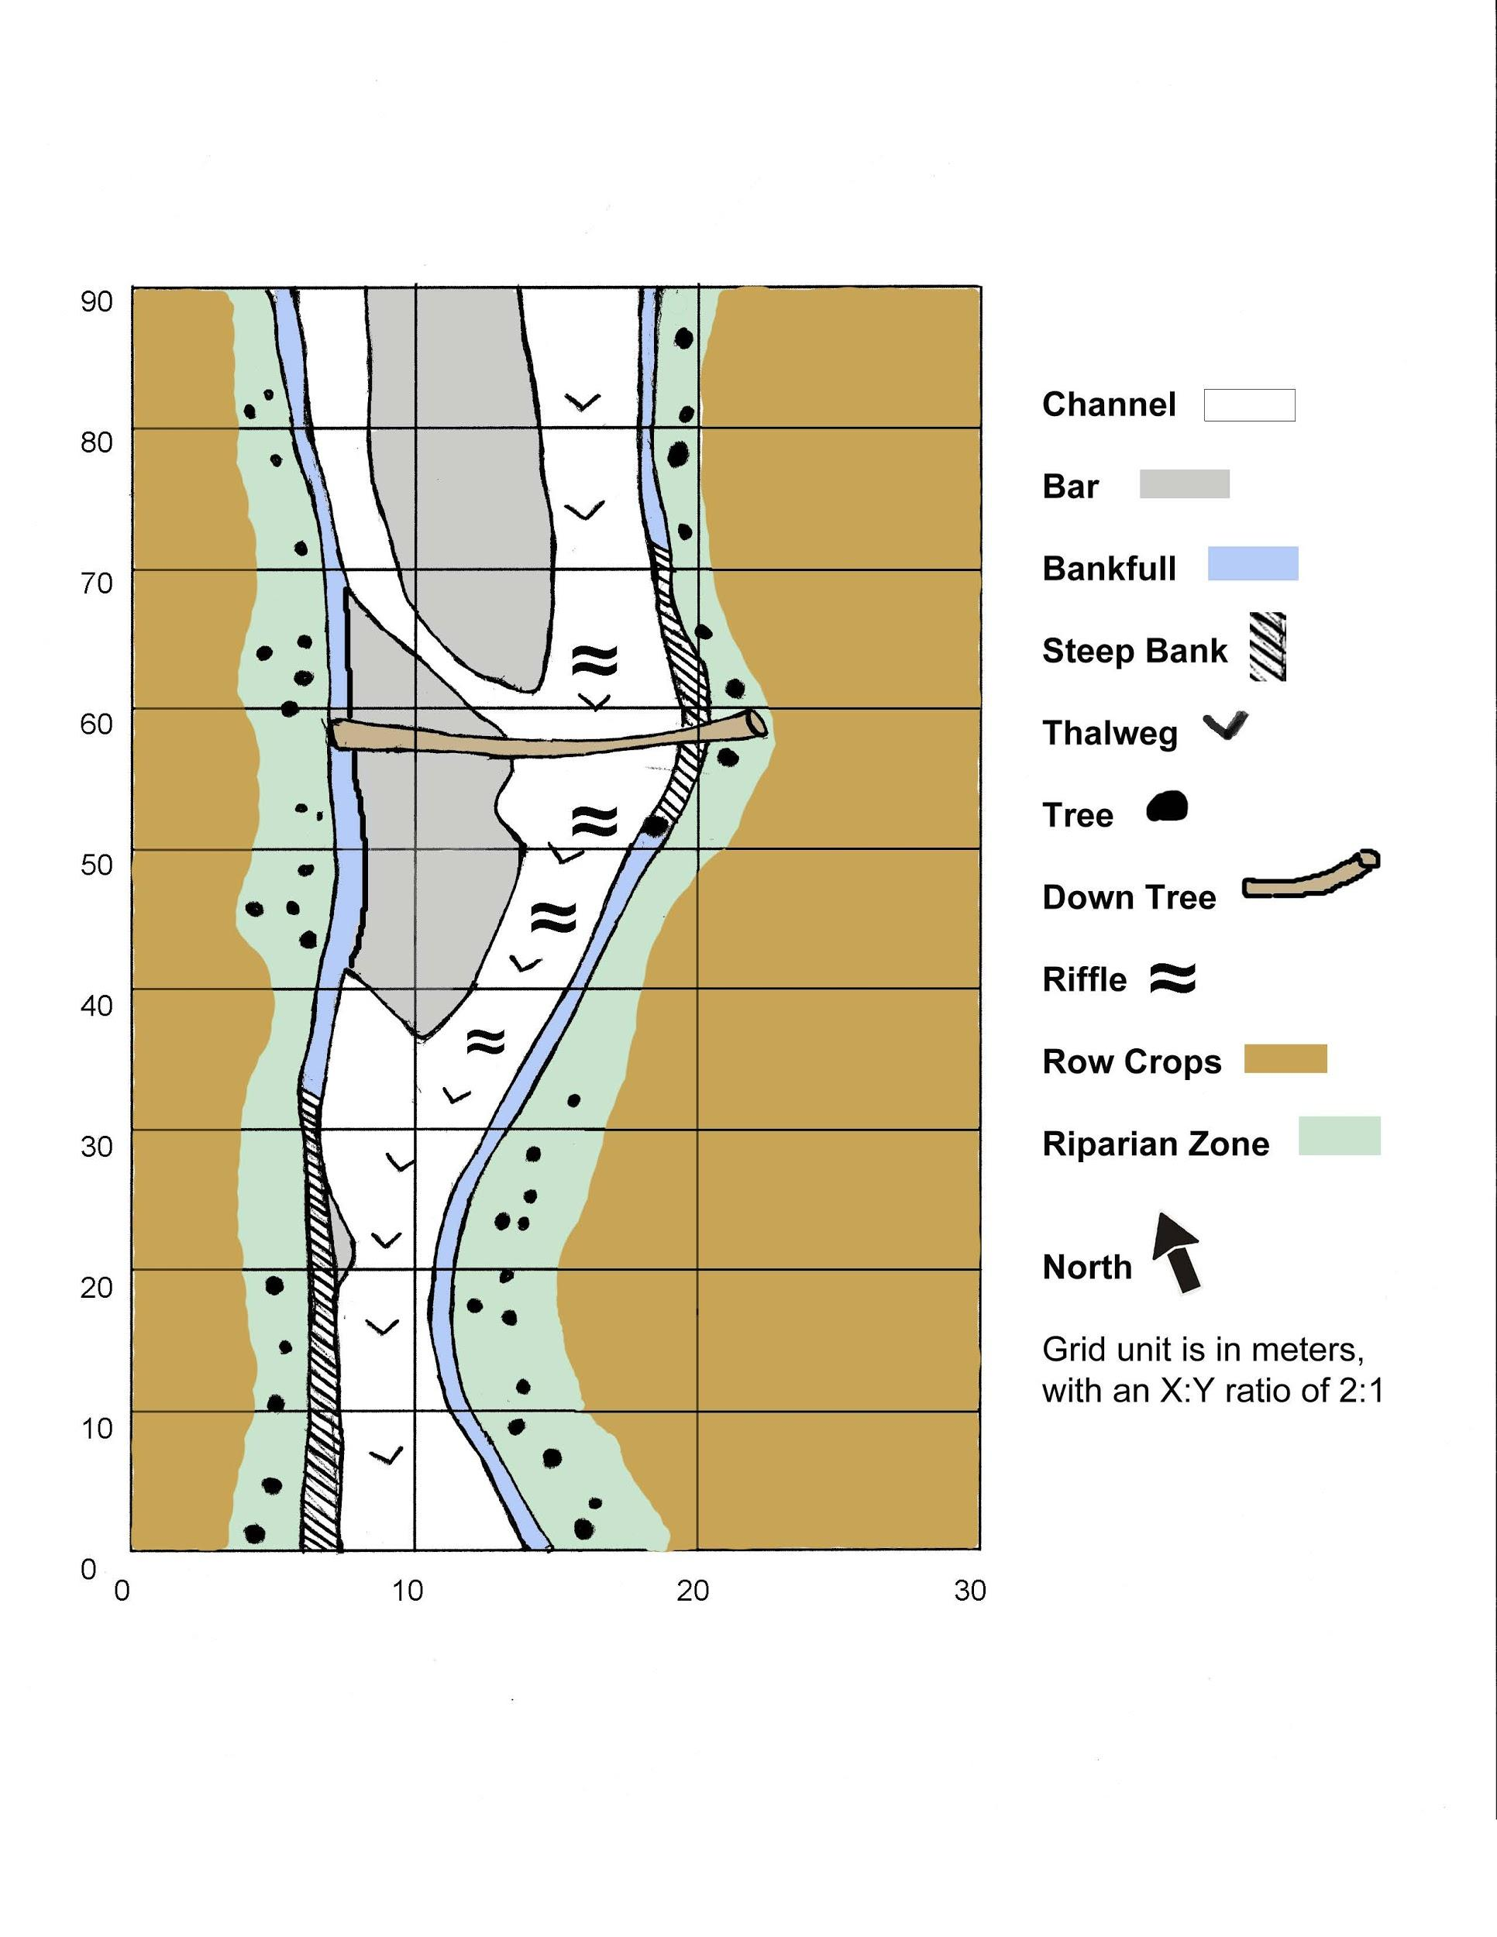

**Figure 1.** Site sketch of Stephen’s Creek reach located in Bloomington, IN.

# III. Methods

# 

# *Physical Characteristics*

Qualitative Habitat Evaluation Index and Substrate Characterization

Stephen’s creek physical habitat was evaluated using the Qualitative Habitat Evaluation Index (QHEI) developed by the Ohio Environmental Protection Agency for streams and rivers (Rankin, 1989). Each group member completed an individual QHEI and the final QHEI score was determined collectively. Substrate analysis was conducted using the Wolman pebble count method (Wolman, 1954).

Discharge, Turbidity & TSS

We used a top-setting wading rod and Flo-Mate Electromagnetic Induction Current Meter to measure velocity and stream discharge on six occasions from February to April. Manning’s roughness (n) was calculated using field observations. Manning’s (n) was used to calculate a velocity and discharge rate for the stream. TSS samples were filtered, dried and measured on March 11, 2016 and March 25, 2016.

Light, Temperature, Conductivity and Dissolved Oxygen

A YSI sonde was deployed to obtain a continuous measurement of dissolved oxygen from 9am (DO in mg L-1) on the morning of February 26 through 7am on the morning of February 29th. The sonde also measured continuous temperature, specific conductivity and percent DO. A PAR sensor was also deployed simultaneously at the sampling site. Turbidity samples were collected on 5 occasions and analyzed in the lab with a turbidimeter.

# *Chemical Characteristics*

Nutrients, pH & Alkalinity

Water samples for nutrient analysis were collected in duplicate during each sampling period. The first sampling occurred on 12 February 2016. The second sampling was completed on 25-March-2016. Water samples were collected via cup-on-a-stick or bottle dip methods. Analytes of interest were nitrogen as Nitrate (NO3-), nitrogen as ammonium (NH4+), soluble reactive phosphorus (SRP), and total phosphorus (TP). Alkalinity as mg of CaCO3 and pH were also measured during each sampling period. Sample pH was measured using a benchtop pH probe. Alkalinity was measured using a benchtop pH probe to monitor acid titration of 100mL sample with 0.2 N H2SO4. Nutrient samples were processed and analyzed with an autoanalyzer in Dr. Todd Royer’s laboratory at Indiana University’s Bloomington campus.

# *Biological Characteristics*

Periphytic Chlorophyll-a, Ash Free Dry Mass, E.coli & Total Coliforms

On February 19, 2016 we quantified periphytic chlorophyll-a (chl-a) and ash free dry mass (AFDM) on three natural rocks and also on a ceramic tile we placed in Stephen’s Creek on January 29, 2016. To remove the periphyton, a plastic template was placed on the rock or tile surface, and periphyton was removed within the template area (Figure 2). Further sampling of periphyton on two natural rocks was done on March 4.

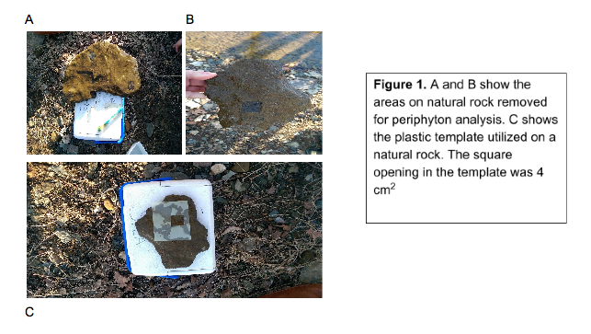

**Figure 2.** A and B show the areas on natural rock removed for periphyton analysis. C shows the plastic template utilized on a natural rock. The square opening in the template was 4 cm2.

We used the gravimetric approach to determine AFDM in the laboratory. Samples were dried and weighed, oxidized in a muffle furnace, and then reweighed. Periphytic chl-a samples were analyzed with a spectrophotometer. Chl-a and AFDM results were then used to calculate an autotrophic index (AI), which is a ratio of AFDM (mg cm-2) to chl-a (mg cm-2).

Whirl-Pak bags were used to collect samples for E. coli and total coliform counts on February 12, 2016 and April 1, 2016. One mL, 10 mL and 50m mL samples of E. coli and total coliform were cultured in liquid medium and culture forming units were quantified after 24 hours.

Estimates of Productivity and Respiration

We were able to calculate productivity and respiration using the dissolved oxygen and percent saturation data from the YSI sondes by following the single station technique described in Methods in Stream Ecology (Bott, 1996).

Macroinvertebrates & Fish

We calculated the Indiana Department of Environmental Management’s (IDEM) Macroinvertebrate Index of Biotic Integrity (mIBI) using protocol outlined by the Department. Kick samples of macroinvertebrates were collected from Stephen’s Creek on both February 26 and March 5, 2016. Samples were collected from all types of in-stream habitat present in the study reach (including pools, riffles, and leaf-packs). Hester-Dendy samplers, which were placed in the stream one month prior to sample collection, were also collected .

All samples were stored in 95% ethanol and 100-organism random sub-sample was selected from these kick samples on both days. Organisms in the sub-samples were identified to the family level, and those taxa were associated with their corresponding tolerance, functional feeding group and habit values.

Fish were sampled and identified on the morning of April 1, 2016 using a seine net. We calculated the IDEM’s Fish Index of Biotic Integrity (IBI) using protocol outlined by the Department (IDEM).

# 

# IV. Results

# 

# *Physical Characteristics*

Qualitative Habitat Assessment & Substrate Characterization

The site received an overall QHEI score of 51 in February and 62 in April. Regarding headwaters, this metric translates into a narrative habitat quality score of “fair” and increased to “good” in April. The following forms of instream cover were present in very small to moderate amounts at the site: undercut banks, shallows, root wads and logs or woody debris. Riparian width was lessRiffles were poorly developed but pools exhibited more variation in depth. Overall, the channel appeared to maintain stable riffle/pool characteristics, but some erosion was present on both banks. Maximum pool depth increased between the samples periods. Results from the Wolman Pebble count are listed in Figure 3.

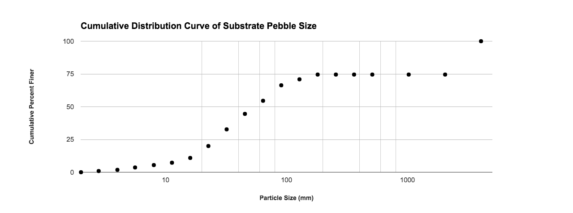

**Figure 3.** Wolman Pebble count at Stephen’s Creek in Bloomington, IN.

Discharge, TSS & Turbidity

Results for discharge, TSS and turbidity are summarized in Table 1. A high discharge value of 14.19 cfs was recorded on February 26 and a low discharge value of 0.53 cfs was recorded on February 5. TSS was 9.18 x 10-7 mg ml-1 on March 3 and increased to 2.13 x 10-6 mg ml-1 on April 1. Turbidity values ranged from 1.5 NTU on January 29 to 7.8 NTU on April 1.

**Table 1.** Discharge, TSS and turbidity measurements for Stephen’s Creek in the winter and spring of 2016.

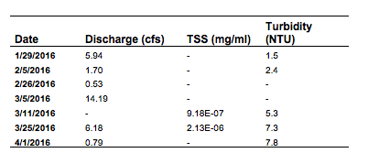

Light, Temperature, Dissolved Oxygen and Conductivity

On February 26 water temperature reached a high of 7.04°C at 3:30pm and a low of 3.09°C at approximately 8:30am (Figure 4). The next two days followed a similar pattern but temperatures increased overall. Maximum and minimum temperatures on February 27 were 8.4 °C and 3.8 °C, respectively. On February 28, temperatures rose to a high of 11 °C.

PAR reached a high of 11,883 mol m-2 sec-1 at 11:10am on the 26th (Figure 5). On the 27th, the highest recorded PAR mol m-2 sec-1 also occurred at 11:10am. The highest PAR value (11,143 mol m-2 sec-1) on the 28th was recorded at 10:30am. PAR fell to zero at approximately 7pm on all three days.

DO was about 13 mg L-1 from deployment (9am on 2/26) to 9am on February 27 when the concentration increased to 14.19 mg L-1 (Figure 4). During the afternoon of the 27th, the concentration decreased to 12.66 mg L-1 and reached a high of 13.76 mg L-1 at approximately 8:50am on the 28th. This pattern continued and there was a decrease in DO during the afternoon of the 28th and an increase on the morning of the 29th. Overall, the range of conductivity values from February 26 to 0.16 𝜇S cm-1 increased slowly from 0.14 𝜇S cm-1 on to on the February 27 (Figure 5).

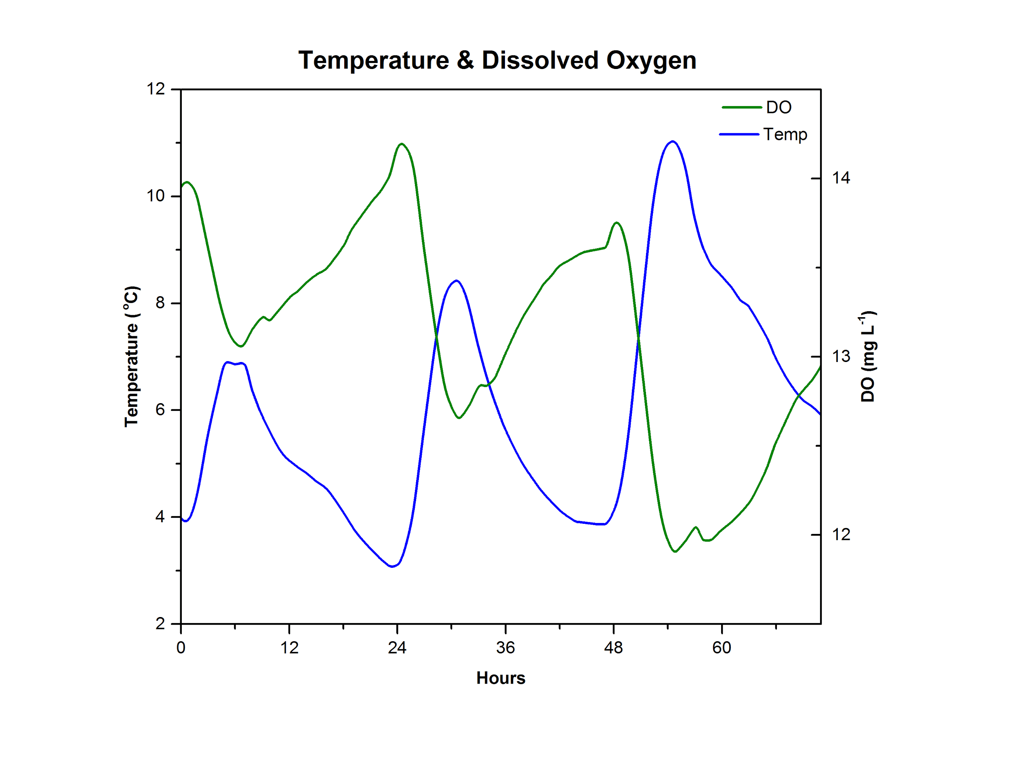

**Figure 4.** Temperature (oC) and dissolved oxygen (mg L-1) measurements at Stephen’s Creek in Bloomington, IN from 9am on 2/28/16 to 7am on 2/29/16.

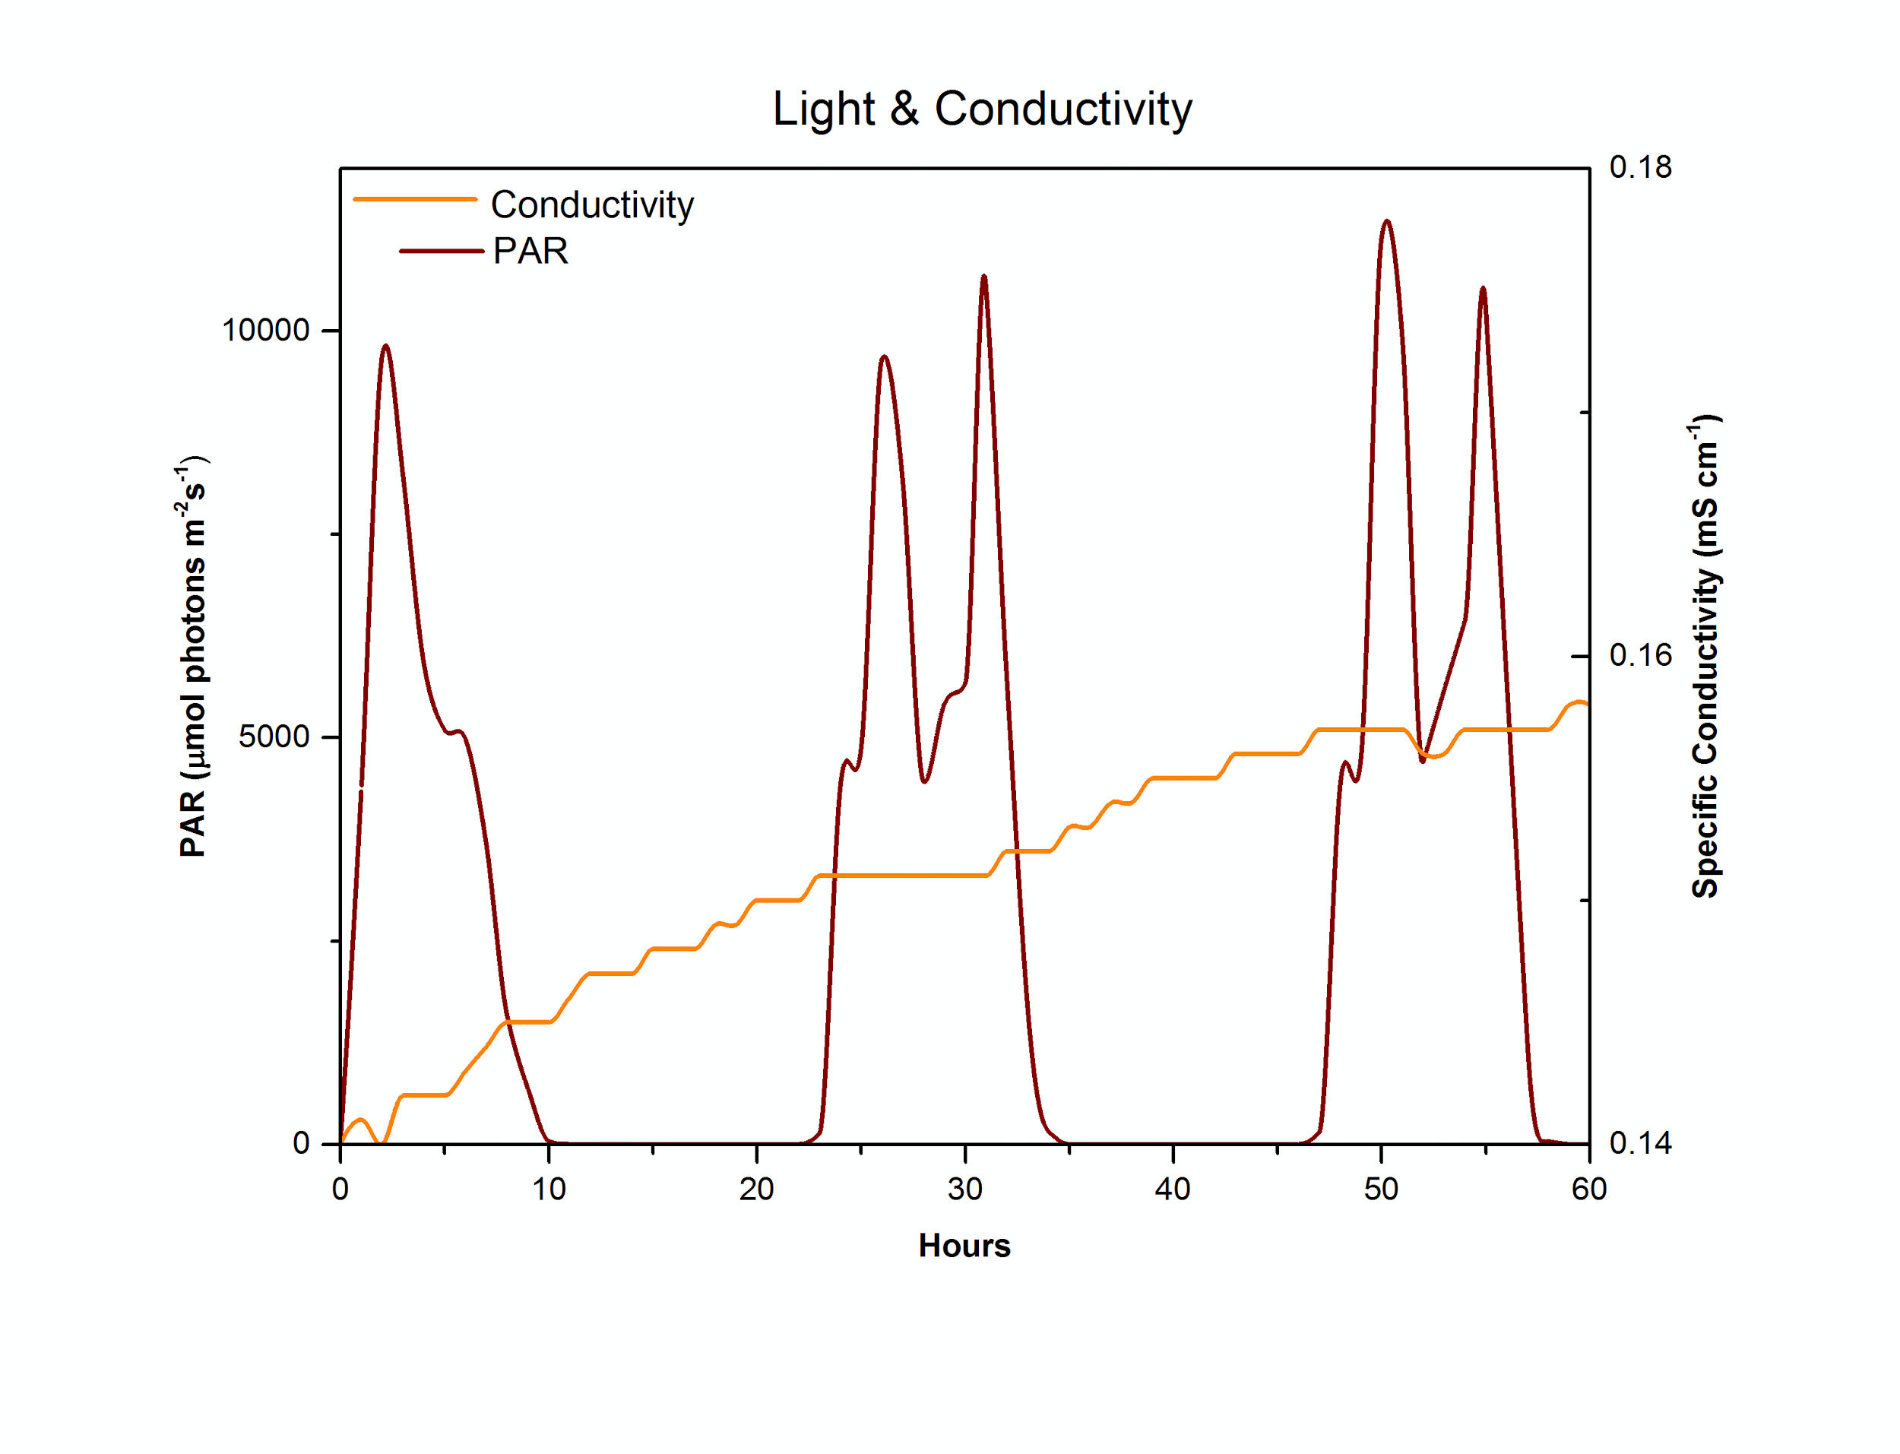

**Figure 5.** Photosynthetically Available Radiation (PAR in 𝛍mol photons m-2 s-1) and conductivity (𝜇S cm-1) measurements at Stephen’s Creek in Bloomington, IN from 9am on 2/26/16 to 7am on 2/29/16.

# *Chemical Characteristics*

Nutrients, pH & Alkalinity

Nutrient concentrations from sampling dates are shown in Table 2. These results show an increase in SRP from 3.2 to 14.9 𝜇g/L and in TP from 12.6 to 64.4 𝜇g/L. Results show a decrease in NO3- from 800 to 330 𝜇g/L for the same sampling period. Alkalinity decreased from 61 to 51 mg as CaCO3. Turbidity increased from 1.38 to 2.89 NTU. Relative percent changes for each of these parameters is indicated in Table 2 but the general trend was an increase between the two sampling periods except for NO3- and Alkalinity, which remained relatively consistent during sampling period.

**Table 2.** Nutrient data for Stephen’s Creek samples. Analytes include nitrate, ammonium, soluble reactive phosphorus and total phosphorus.

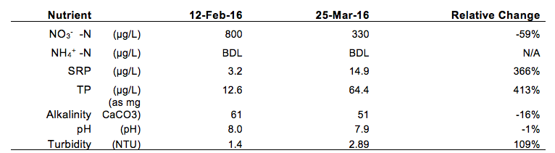

# 

# *Biological Characteristics*

Periphytic Chlorophyll-a, Ash Free Dry Mass & E. coli

The AFDM densities found on each of the three natural rocks collected on February 19 were 3.25, 3.03, and 3.20 mg cm-2 respectively (Figure 6). The AFDM from the tile was 0.28 mg cm-2. Chl-a density was 133.1, 151.8, 156.9 mg m-2 on the three natural rocks sampled on February 19 (Figure 7). The ceramic tile yielded 8.0 mg m-2 of chl-a. The AI for the natural substrate was 215 and the AI for the artificial substrate was 348.The two rocks sampled on March 4 had chl-a densities of 23.7 and 22.3 mg m-2 and AFDM densities of 0.72 and 0.83 mg cm-2 (Figure 6; Figure 7).

On February 12, 0 colony forming units were observed of E. coli and total coliform. On April 1, 882 cfu 50 ml-2 of total coliform and 60 cfu 50 ml-2 of E. coli were observed.

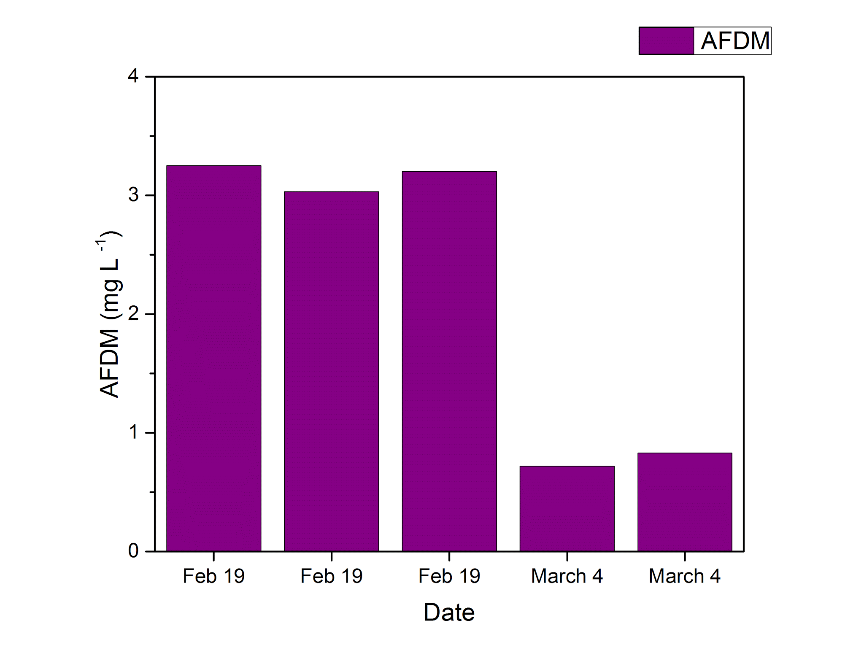

**Figure 6.** The AFDM densities found on each of the three natural rocks collected on February 19, 2016 and two natural rocks on March 4, 2016 in Stephen’s Creek.

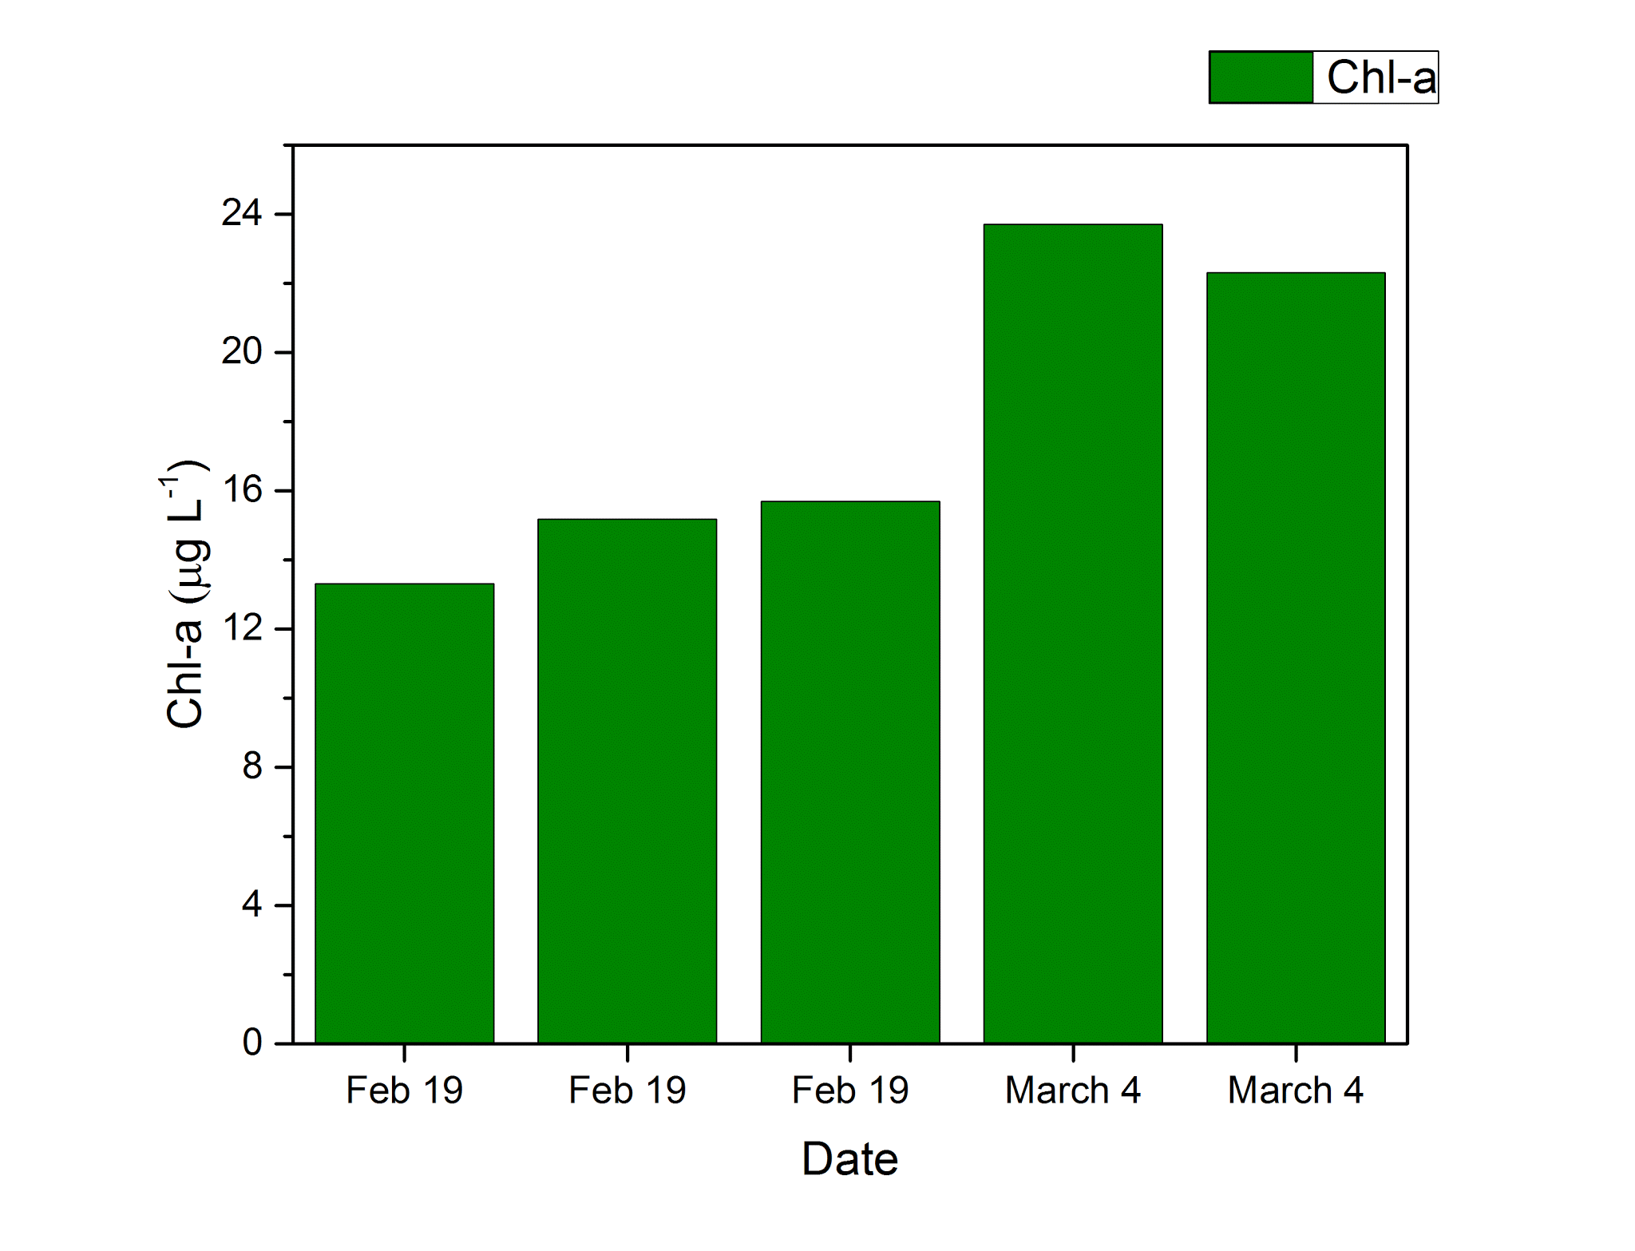

**Figure 7.** The chl-a densities found on each of the three natural rocks collected on February 19, 2016 and two natural rocks on March 4, 2016 in Stephen’s Creek.

Estimates of Productivity and Respiration

We determined that gross primary productivity (GPP) was equal to 10.91 g O2 m-2 day-1 and Community Respiration over 24 hours (CR24) was 3.415 g m-2 day-1. Using these two parameters we were able to determine Net Ecosystem Production (NEP) was 7.516 g O2 m-2 day-1.

Macroinvertebrate and Fish Index of Biotic Integrity

We collected and identified 221 macroinvertebrate individuals composed of 31 different taxa. The mIBI score for Stephen’s Creek based on the combined samples on February 26, 2016 and March 5, 2016 is 36 (+2-4). The mIBI score for the Hester-Dendy samplers is 26 (+2-4). We were unable to Identify Diptera Chironomidae beyond family level in the laboratory. We assumed all Diptera Chironomidae organisms in our sample were Orthocladiinae and Tanytarsini producing an mIBI metric score of 1, but a different outcome could lead to a total mIBI score increase of 2-4 points. The most common orders of macroinvertebrates included Amphipoda, Coleoptera, Diptera, Isopoda, Plecoptera, Trichoptera and Ephemeroptera (Figure 8).

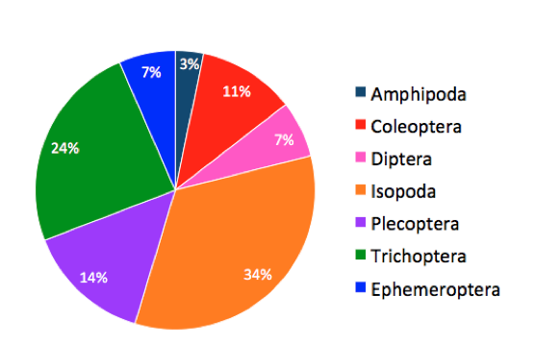

**Figure 8.** The most common orders of macroinvertebrates found in Stephen’s Creek on February 26 and March 5, 2016.

Two hundred six fish made up of eight species of fish were collected from Stephen’s Creek (Figure 9). Common Stoneroller, Campostoma anomalum, was the most common species followed by the orange throat darter, Etheostoma spectabile, and the striped shiner, Luxilus chrysocephalus. Stephen’s Creek had a fish Integrity of Biotic Index of 40.

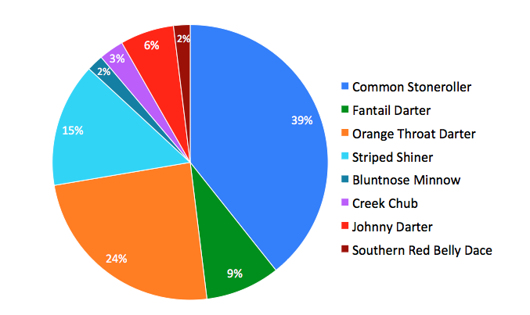

**Figure 9.** Composition of species collected in Stephen’s Creek on April 1, 2016 using a seine net.

# V. Discussion

# 

# *Physical Characterics*

Light, Temperature & Dissolved Oxygen

There is often a strong linear relationship between air temperature and river water temperatures (Wetzel, 2001). Predicted daytime air temperatures over the sampling period were 4°C, 13°C and 19°C respectively. There was an upward trend though maximum temperatures for Stephen’s Creek did not reach air temperatures on the 27th or 28th. Groundwater seepage was observed at the site and will play an important role in determining the stream’s temperature. Diurnal temperature variations are typically observed in shallow streams exposed to solar irradiance (Wetzel, 2001). Our stream reach has a limited buffer zone (less than 5 meters) and exhibits a low percentage of vegetative cover. PAR readings at Stephen’s Creek may also be a function of sparse vegetative cover and a limited buffer zone. Research suggests that dense vegetative cover can block more than 95% of PAR (Allan & Castillo, 2007). Stephen’s Creek PAR levels were high relative to Kerr Creek, another second order stream located within the same watershed with high percent vegetative cover and landscape shading (Figure 5).

# *Chemical Characteristics*

Nutrients, pH & Alkalinity

Precipitation can cause soil erosion in the landscape which acts as a major source of sediment in rivers and streams (House, et. al. 1998). This sediment can have significant impacts on phosphorus content of the waterway due to the introduction of phosphorus sorbed to the sediment particles (Froelich, 1988) acquired from overland flow. The March sampling period for this study followed a rain event which resulted in increased discharge in the Stephen’s Creek study reach. The nearly 500 percent increase in total phosphorus seen in the sample analyses we attribute to this phenomenon.The Stephen’s Creek study reach is surrounded on both sides by agricultural land which most likely provides the source of phosphorus.

The bedrock within the Stephen’s Creek watershed and specifically within the study reach is primarily limestone which provides a virtually limitless input of CaCO3. This input helps to maintain relatively constant alkalinity within Stephen’s Creek despite changes in pH from precipitation events and other inputs. Although this supply is readily available, some fluctuation does occur due to equilibration time between acidic inputs and bedrock dissolution.

# 

# *Biological Characteristics*

Periphytic Chlorophyll-a and Ash Free Dry Mass

Chl-a density on natural substrate was greater on February 19, 2016 than on March 4, 2016. This is likely due to rain events that scoured periphyton from the rock surfaces prior to the later sampling date.

AI values greater than 200 can suggest that the periphyton assemblage is dominated by heterotrophic organisms (Weber 1973, Weitzel 1979, Matthews et al. 1980). This may result from an input of degradable organic matter being discharged into the water causing the biomass of heterotrophic microorganisms to increase more rapidly than the biomass of the algae (Collins & Weber, 1978). In Stephen’s Creek, the AI values of 215 (natural substrate on 2/19), 338 (natural substrate on 3/4), and 348 (artificial substrate) indicates dominance by heterotrophic microorganisms. The high availability of PAR (Table 1) exhibited at Steven’s Creek could help to explain higher biomass.

Productivity and Respiration

Productivity and respiration show that Steven’s Creek was experiencing a significant amount of primary productivity and low levels of respiration during the monitoring period. Estimated GPP is consistent with expected values for an Indiana stream that receives high light levels. There was a heavy rain event prior to sampling and it is likely that this stream would have exhibited a higher GPP if samples were taken before scouring . Substrate exhibited scouring after the rain event. For comparison, a study of the White River conducted in July 1933 estimated a GPP rate of 57 g O2/m2/day (Denham, 1938). The size of the White River and the season in which it was sampled might explain why GPP estimates are higher than our estimates of Stephen’s Creek. For this reason, the GPP to CR ratio might be a better method of comparison. The GPP to CR ratio was 3.2 for both streams. A study of 14 rivers in the Midwest and Western US found a GPP range of 0.6-22 gO2/m2/day, which is consistent with our findings (Hall, 2016).

Though GPP to CR ratios in this study were all less than one, a full meta analysis of the dataset, revealed that small streams have a potential for both high and low GPP to CR ratios.

Macroinvertebrate & Fish Index of Biotic Integrity

IDEM mIBI scores greater than or equal to 36 are considered unimpaired. Therefore, Stephen’s Creek is considered unimpaired, but by only one point. This score is likely to change based on seasonal differences in macroinvertebrate assemblage. According to Karr et al., (1986), a fish IBI score of 40 is in the “fair” integrity class. It indicates that the stream exhibited signs of deterioration including the loss of some intolerant species and a highly skewed trophic structure (Karr et al., 1986).

# *Comparison & Long Term Trends*

Comparison to Similar Streams

Results for nutrients, PAR, DO, temperature, and conductivity were compared with median values from Kerr Creek, Silver Creek and Indiana ecoregions. Overall results are summarized below (Table 3). Kerr Creek is another second order stream in Bloomington, IN with similar watershed characteristics. Silver Creek is a 38 mile tributary of the Ohio River and is located in Southern Indiana. Overall, nutrient measurements taken during the spring at Stephen’s Creek fall below the state median value but were similar to Kerr Creek. PAR is higher at Stephen’s Creek relative to Kerr Creek. This is most likely due to differences in percent vegetative cover. Dissolved oxygen levels were high were compared with Silver Creek and Indiana median values and just slightly higher than Kerr Creek. Increased PAR at Stephen’s creek would positively impact DO production. Conductivity at Stephen’s Creek was similar to Kerr but low when compared with Silver Creek and Indiana State values. Freshwater streams have a typical conductivity range of 150-500 𝛍Sm cm-1 and higher measurements may be an indicator of pollution (Behar, 1997). This may be relevant for Steven’s Creek, where the watershed is predominantly forest and nutrient levels were lower than the state median value by an order of magnitude.

**Table 3.** Results of the measurements conducted at Stephen’s Creek in Bloomington, IN during Feb-March 2016 sampling and comparison to Kerr Creek and Silver Creek.

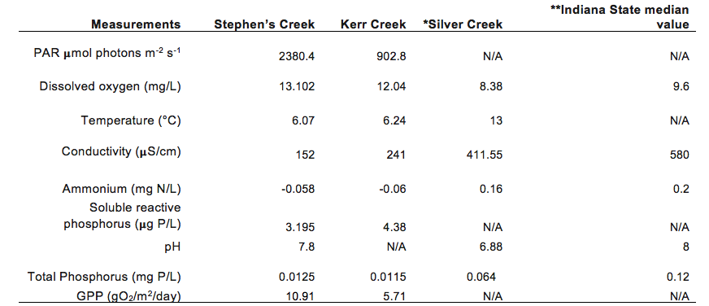

We compared our QHEI results with two other streams within Monroe county: Clear Creek and Middle Fork Salt Creek. Our site received a lower score comparatively. However, the difference in scoring is most notable in the instream cover category. If we were to do carry out another QHEI in the summer, this scoring gap may narrow (Table 4). We also compared our score to four streams in east central Indiana: Bell Creek, Buck Creek, Little Killbuck Creek and Killbuck Creek. Land use surrounding the streams was 70% agriculture, and many of the streams showed some degree of channelization. Table 5 shows the range of QHEI scores found for each stream. Scores ranged from 31.5-83, and Stephen’s Creek is toward the upper end of this range (Sullivan et al., 2004).

**Table 4.** Results from QHEI conducted at Upper Stephen’s Creek in Bloomington, IN on 2/5/16 and 4/10/16 and two comparison sites located within Monroe County (*Data).

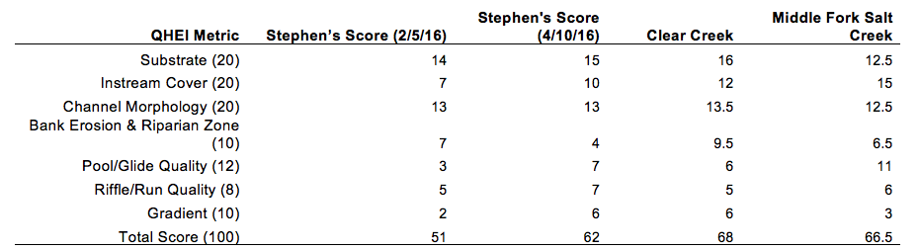

**Table 5.** Comparison of Stephen’s Creek QHEI, Fish IBI, mIBI and AI to Indiana streams (Sullivan et al., 2004; Voelker, 2004).

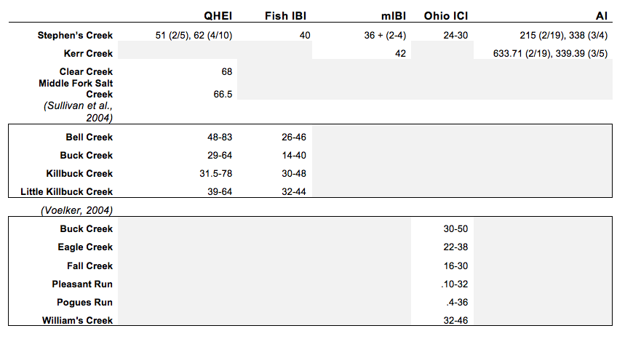

The study in east central Indiana also evaluated the fish IBI for each of the four streams. A total of 48 species were collected at the four sites, in comparison to the 8 species collected at Stephen’s Creek. The most common species found in east central Indiana were creek chub, *Semotilus atromaculatus*, and mottled sculpin, *Cottus bairdii*, compared to the common stoneroller and orangethroat darter found at Stephen’s Creek (Sullivan et al., 2004). These sites had IBI values from 26-48 and Stephen’s Creek falls into the upper end of this range.

Several studies used a similar index to the mIBI, the Ohio EPA’s Invertebrate Community Index. We calculated Stephen’s Creek score using the ICI in order to conduct additional comparative analysis. Stephen’s Creek was given a score range of 24-30, which indicates fair quality. A 1999 USGS study evaluated 6 tributaries to the White River in Indianapolis Metropolitan Area that were affected by combined sewer overflow pollution. Each tributary had several sampling sites and stream QHEI values ranged from 4-50 (Voelker, 2004). The Stephen’s Creek score fell into the middle of the range of QHEI scores of the urban streams.

AI values were compared to Kerr Creek’s AI values from data collected on approximately the same days. On the February sample date Kerr Creek has a much higher AI of 633 compared to 215 in Stephen’s Creek. Values greater than 400 typically indicate organic pollution (US EPA, 2000). Kerr Creek is directly against a road and is bordered by a forested ravine, which decreases sunlight availability to the stream. These factors may increase organic input and lower chl-a production, driving the AI score up. The two streams have nearly identical AI ratios on the March sampling date. This was following a storm event and both streams experienced significant scouring.

# 

# *Trends 2006-2016*

QHEI

We compiled QHEI scores from 2008-2016. As the graph indicates, Stephen’s Creek received narrative scores within the “Good” range for headwater streams from 2008-2014. This qualitative trend suggests that the quality of habitat provided by Steven’s Creek has remained relatively constant over the 10 year sampling period. As the name suggests, this metric is simplistic and while it may be a useful regulatory tool for comparing stream quality on a larger scale, nuances in stream habitat changes are not captured in the score.The differences in scores could be do to the subjective nature of the QHEI.

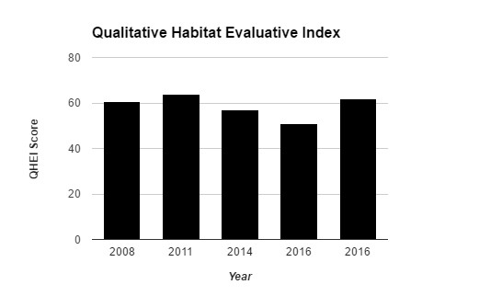

**Figure 10.** QHEI scores gathered from 2008, 2011, 2014, and two from 2016. The first 2016 being in February and the second in April.

Macroinvertebrates IBI

Over the ten year sampling period, IBI scores placed this reach in between the “poor” and “fair” narrative categories. Both Isopods species present in all years are designated as more tolerant species by the index (Figure 11). We see that IBI scores were lowest in three years this order was most abundant. IBI scores seemed to recover as more sensitive species became more abundant. The historical data includes a period of extreme drought in 2012. This type of disturbance could certainly have changed the macroinvertebrate community within Stephen’s Creek.It is important to note that the number of taxa and the number of individuals has an impact on the score. This means that sampling time is an important factor. Overall, Stephen’s Creek has historically exhibited a high percentage of pioneer and tolerant species, which could help to explain historically low IBI scores.

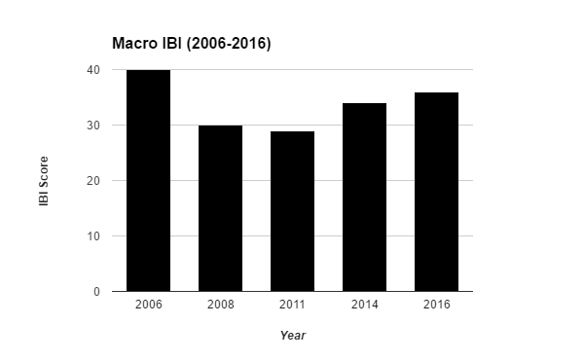

**Figure 11.** Macroinvertebrate IBI scores gathered from 2008, 2011, 2014, 2016.

Fish IBI

We also compared Fish IBI calculated from 2006-2016 using the species identified during catches (Figure 12). Overall scores sat on the threshold between two categories: “fair”, which indicates that many intolerant and sensitive species are absent from the reach; and “poor”, which suggests that top carnivores and many expected species are absent or rare and that omnivores and tolerant species are dominant. In 2008 there was a low catch rate which could affect the IBI score due to the percent abundance of each species.Common stone roller, a pioneer species, is most abundant in all three years. Creek chub (a tolerant pioneer species) was common 2006 and 2008 and then declined in 2016. Orange throat darter (an insectivore and pioneer species) and striped shiner populations increased over three years while the Southern Red Belly Dace (a sensitive species) remained relatively constant.

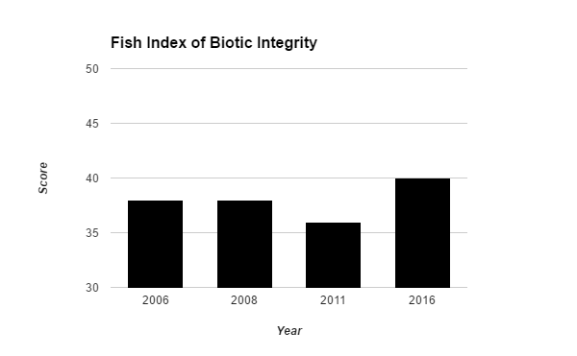

**Figure 12.** Fish IBI scores gathered from 2008, 2011, 2014, 2016.

Nutrients, AFDM, Chl-a & Discharge

Years exhibiting high average discharge values also exhibited lower average AFDM and chl-a (Figure 13). We observed souring after heavy rains in 2016. In a study conducted by Bernot et. al (2016), high whole-stream uptake rate of phosphorus and ammonium associated with the observed presence of stream autotrophs, or algae and macrophytes. Scouring may slow uptake. In 2014, low average concentrations of chl-a and AFDM corresponded with high phosphorus and ammonium concentrations (Figure 14). Low concentrations of chl-a and AFDM may also have been influenced by low nutrient levels (Figure 15).

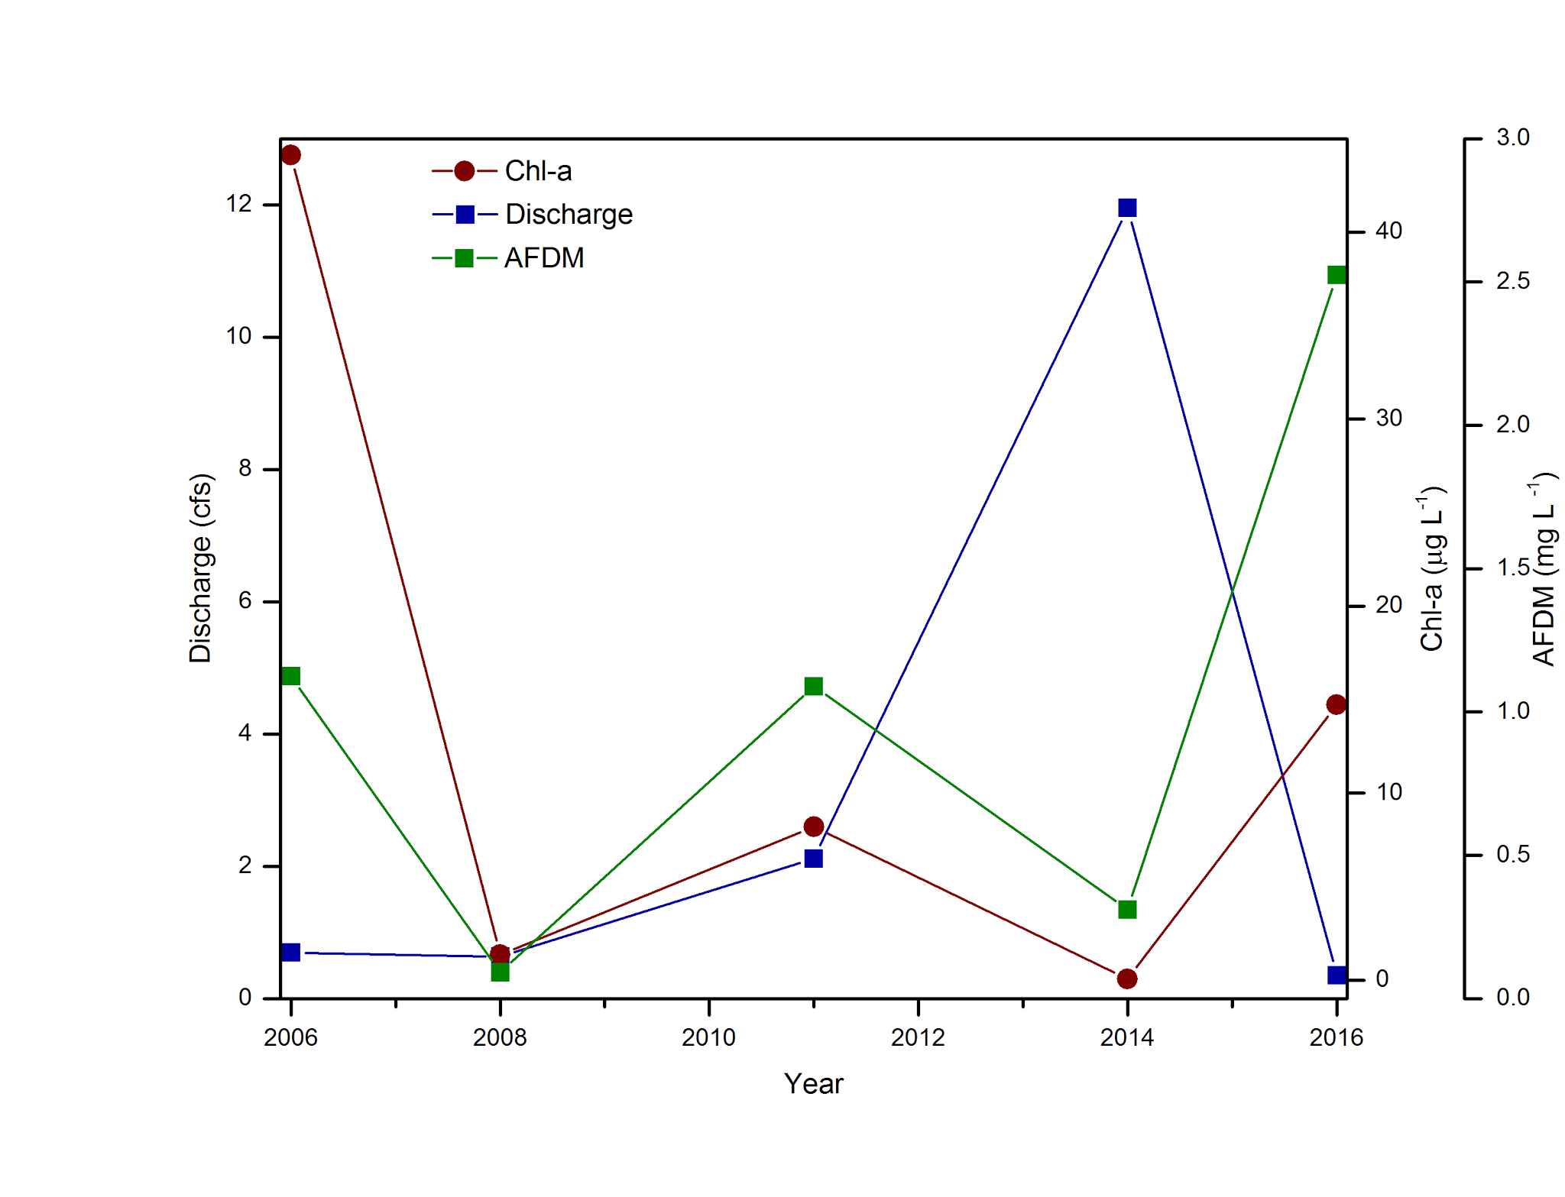

**Figure 13.** Chlorophyll-a, ash free dry mass, and discharge gathered from 2008, 2011, 2014, 2016. Chlorophyll-a in ug/L and AFDM in mg/L. Average Discharge is in cubic feet per second.

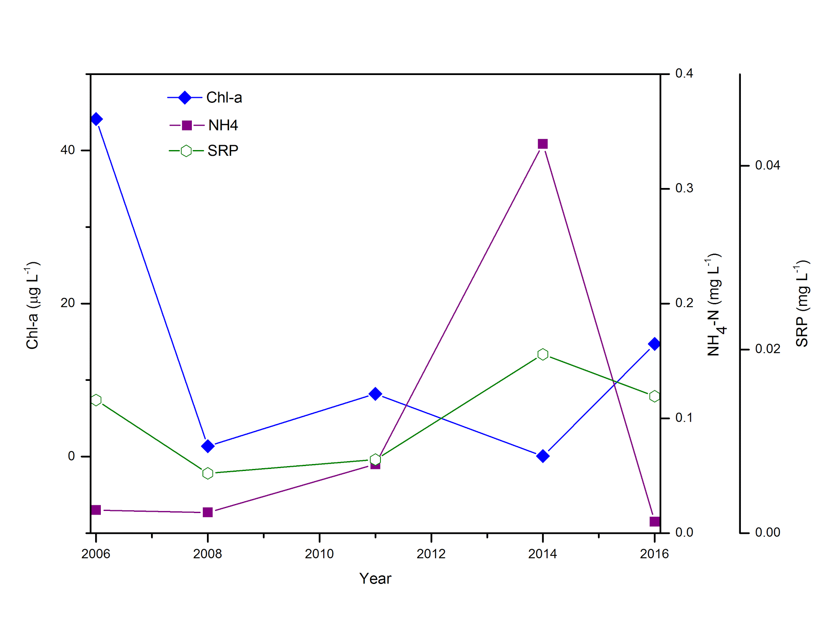

**Figure 14.**  Chl-a, ammonia and SRP gathered from 2008, 2011, 2014, 2016.

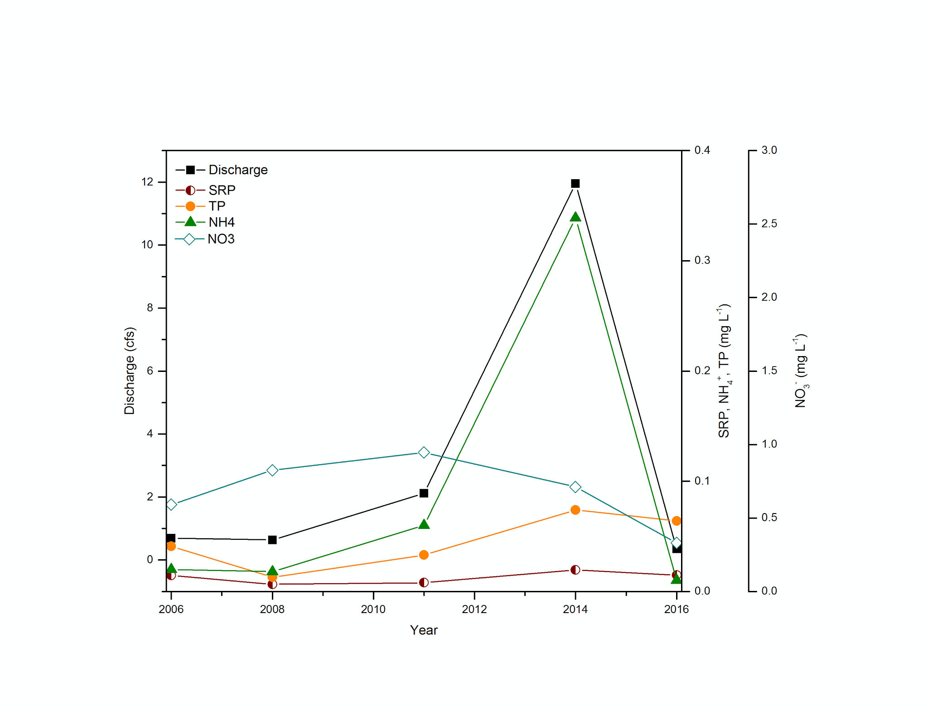

**Figure 15.** Discharge, SRP, TP, ammonia and nitrate gathered from 2008, 2011, 2014, 2016.

# *Conclusion*

Stephen’s Creek exhibited typical seasonal changes in chemical and biological characteristics. Nutrient loads in the Stephen’s Creek are not abnormally high for midwestern streams when compared to the findings of Hall, et. al. (2015). Historically similar mIBI scores indicate little change in the type of community over the reviewed ten year period. While the overall community structure may have changed it has typically been made up of a disproportionate amount of more tolerant species which provides some evidence of poor stream health. A similar trend to that of the macroinvertebrates is seen in the Fish IBI over the same ten year period. Our analysis of AFDM and Chl-a along with our GPP, and CR24 data indicate high presence and productivity within the study reach with some losses due to scouring during a precipitation event.

Overall it appears that Stephen’s Creek is in a “fair” state of health and may still be going through a recovery process from the 2012 drought. Without further details about the biology of species within Stephen’s Creek it is difficult to make a determination as to whether it is truly recovering or in a state of decline. Furthermore, given the landscape and soil makeup of the watershed, recovery from such large disturbances may be difficult. Due to the nature of the bed formation and overall habitat seen in the study reach, it is possibly that adequate refugia may be in limited supply for more tolerant species along the full stream length and upstream movement for more tolerant fish and macroinvertebrate species may be highly affected by extreme changes in discharge during precipitation events within the Stephen’s Creek watershed.

We suggest that further work, possibly in conjunction with the Indiana University Limnology course, include further investigation of more tolerant species present in the Lake Monroe reservoir. Information regarding their habitat and refugia needs in order to reach and repopulate the Upper Stephen’s Creek study site would be greatly beneficial in understanding the gradient of health within the study reach.

Works Cited

Allan, J. D., & Castillo, M. M. (2007). Stream ecology: structure and function of running waters. Springer Science & Business Media.

Behar, S. (1997). Testing the Waters: Chemical and Physical Vital Signs of a River. Montpelier, VT: River Watch Network. ISBN-0-782-3492-3.

BERNOT, M. J., TANK, J. L., ROYER, T. V. and DAVID, M. B. (2006), Nutrient uptake in streams draining agricultural catchments of the midwestern United States. Freshwater Biology, 51: 499–509.

Bott, T. L. (1996). Primary productivity and community respiration. Methods in stream ecology. Academic Press, San Diego, California, 533-556.

Collins, G. B., & Weber, C. I. (1978). Phycoperiphyton (algae) as indicators of water quality. Transactions of the American microscopical Society, 36-43.

Denham, S. (1938). A limnological investigation of the West Fork and common branch of White River. Invest. Indiana Lakes and Streams, 1(5): 17-72.

Fowler, K. K., & Wilson, J. T. (1996). *Low-flow characteristics of Indiana streams* (No. 96-4128). US Geological Survey; Branch of Information Services [distributor].

**Frankenberger J & Esman L. (2012) Department of Agricultural and Biological Engineering Purdue University. Monitoring Water in Indiana: Choices for Nonpoint Source and Other Watershed Projects.

Froelich, P. N., (1988) Kinetic control of dissolved phosphate in natural rivers and estuaries: A primer on the phosphate buffer mechanism. Limnology and Oceanography, 33(Iss. 4, part 2), pp. 649-668

Hall Jr, R. O., Tank, J. L., Baker, M. A., Rosi-Marshall, E. J., & Hotchkiss, E. R. (2015). Metabolism, Gas Exchange, and Carbon Spiraling in Rivers. Ecosystems, 1-14.

House, W. A., Jickells, T. D., Edwards, A. C., Praska, K. E., & Denison, F. H.(1998).

Reactions of phosphorus with sediments in fresh and marine waters. Soil Use and Management, (14), pp. 139-146.

Indiana Department of Environmental Management (IDEM). Guide to Appropriate Metric Selection for Calculating the Index of Biotic Integrity (IBI) for Indiana Rivers and Streams.

Karr, J. R., Fausch, K. D., Angermeier, P. L., Yant, P. R., & Schlosser, I. J. (1986). Assessing biological integrity in running waters. A method and its rationale. Illinois Natural History Survey, Champaign, Special Publication, 5.

Matthews, R. A., Kondratieff, P. F., & Buikema, A. L. (1980). A field verification of the use of the autotrophic index in monitoring stress effects. Bulletin of environmental contamination and toxicology, 25(1), 226-233.

Moerke, A. H., & Lamberti, G. A. (2004). Restoring stream ecosystems: lessons from a midwestern state. Restoration Ecology, 12(3), 327-334.

Sullivan, B. E., Rigsby, L. S., Berndt, A., Jones-Wuellner, M., Simon, T. P., Lauer, T., & Pyron, M. (2004). Habitat influence on fish community assemblage in an agricultural landscape in four east central Indiana streams. *Journal of Freshwater Ecology*, *19*(1), 141-148.

SWCD (2007). Silver Creek Watershed Management Plan A305-6-172.

Thomas, J. A. (1981). Soil Survey of Monroe County, Indiana.

United States Environmental Protection Agency (US EPA). (2000). Nutrient Criteria Technical Guidance Manual: Rivers and Streams.

United States Environmental Protection Agency (US EPA). (2006). Concepts and Approaches for the Bioassessment of Non-wadeable Streams and Rivers.

United States Department of Agriculture (USDA) (1981). Soil Survey of Monroe County Indiana.

Voelker, D. C. (2004). *Biological assessment of streams in the Indianapolis Metropolitan Area, Indiana, 1999-2001* (Vol. 3, No. 4331). US Department of the Interior, US Geological Survey.

Weber, C. I. (1973). Biological field and laboratory methods for measuring the quality of surface waters and effluents. United States EPA Report 670/4/73/001.

Weitzel, R. L., Sanocki, S. L., & Holecek, H. (1979). Sample replication of periphyton collected from artificial substrates. In Methods and measurements of periphyton communities: a review. ASTM International.

Wetzel, R. G. (2001). Limnology: lake and river ecosystems. Gulf Professional Publishing.